|  |  |  |  |  |  |
| --- | --- | --- | --- | --- | --- |
|  |  |  |  |  | logo1.png |

|  |  |  |  |
| --- | --- | --- | --- |
| Course Name | | Zoho Books | |
| College Name | | Mangayarkarasi College of Arts and Science for Women Paravai, Madurai - 625002 | |
| College Code | | MKU251 | |
| Skill Offering Id | |  | |
| Project Title | | Preparation and maintanence of ZOHO books for UrbanAura Interiors | |
| Project Submitted To | | Madurai Kamaraj University ( Naan Mudhalvan Scheme(TNSDC)) | |
| Year | | 2023 | |
| Department | | B.COM Computer Application | |
| Semester | | 5 | |
| Group Number | | 2 | |
| Total Members of the Group | | 4 | |
| Group Members Details | | | |
| Name of the Member | University Register. No | | Student NM ID |
| M.YUVA SRI | C1C15544 | | 1444E078FD3C2C6AA0C4ED2104A5BEB2 |
| M.KAVITHA | C1C15517 | | 66200213E36613583F1484EE1201C3B5 |
| S.NARMATHA | C1C15525 | | 025E7C669A75506A0734BF8635C1898B |
| R.Deepika | C1C15507 | | 2BE016BAE8AC88381CC426DEA5162B7F |
|  |  | |  |
| Under the Guidance | | PUNITHA MARTINA NESAMANI J | |
| SPOC | | Ms.P.UMADEVI | |

**Analysing Housing Prices in Metropolitan areas in India**

1. **Introduction.**

***Urban interior design is a style that combines elements of contemporary, modern, and industrial designs. It's a unique style that's perfect for inner-city living. Urban design is softer and more comfortable than industrial design styles. Urban design can vastly improve the status and value of space. It can stimulate the local economy, attract tourists to the urban area, and improve the quality of life for locals. They may also work to improve traffic flow issues for pedestrians, cyclists, and motor vehicles.***

**Importance:**

**Urban design can vastly improve the status and value of space, which may stimulate the local economy, attract tourists to the urban area and improve the quality of life for locals. They may also work to improve traffic flow issues for pedestrians, cyclists and motor vehicles**

**Purpose:**

**Urban Interiors designs and customizes living spaces, and their goal is to customize your space into your 'happy place. From sprawling villas to tiny studios. they can help you transform your home into the one you've always dreamt of.**

1. **Problem Definition and Design Thinking**

A .Empathy Map

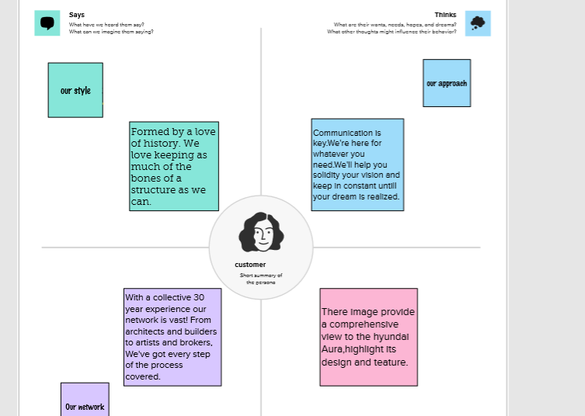

**2.2 Ideation and Brainstroming Map**

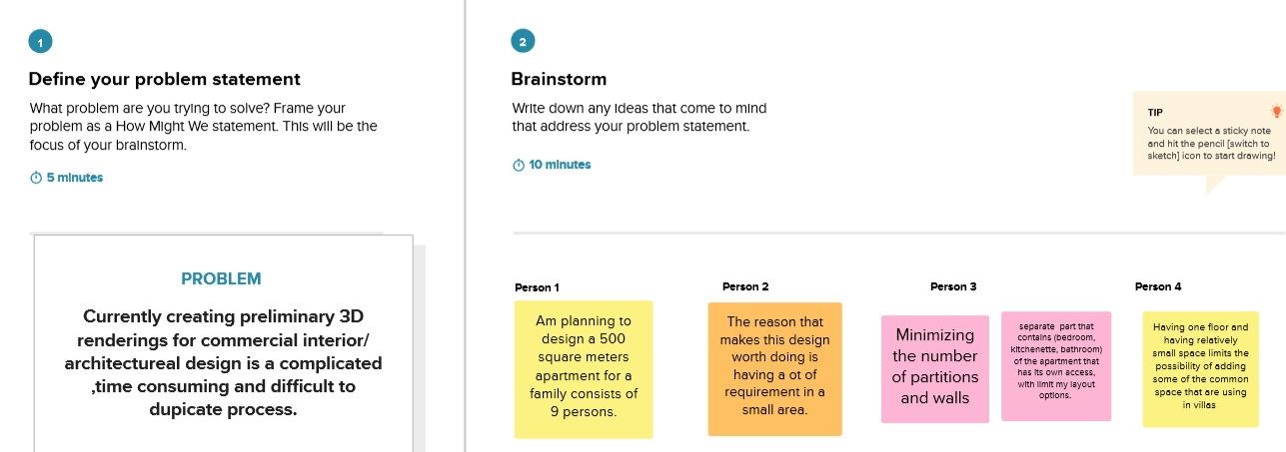

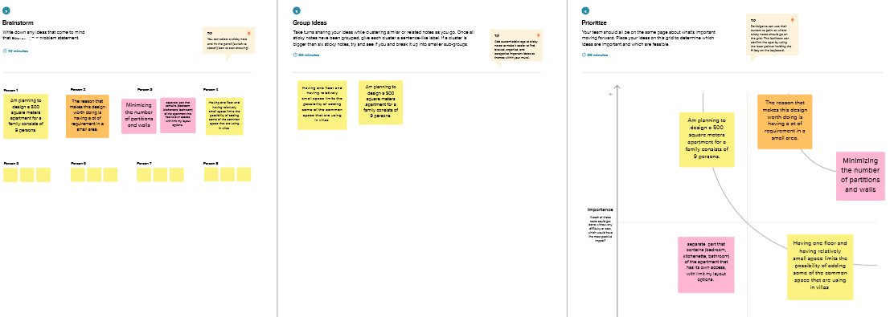

1. **Result:**

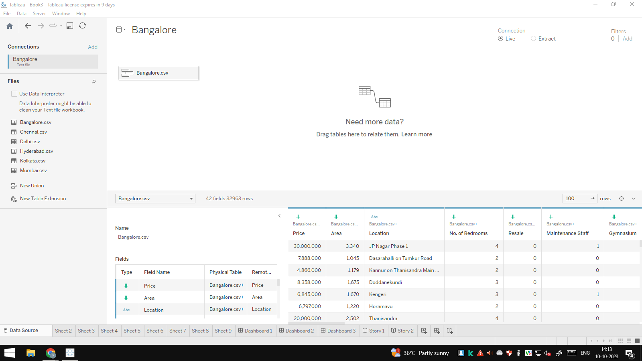

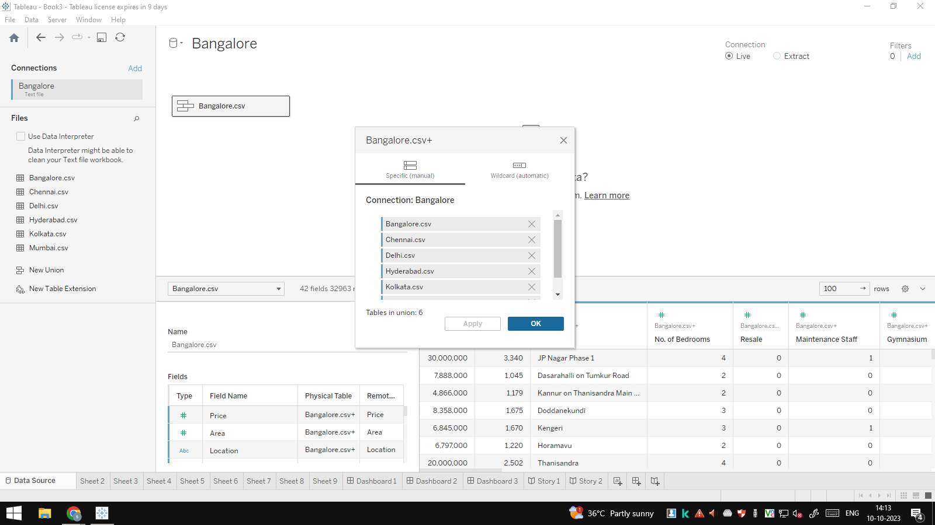

**Milestone 1: Set up your account**

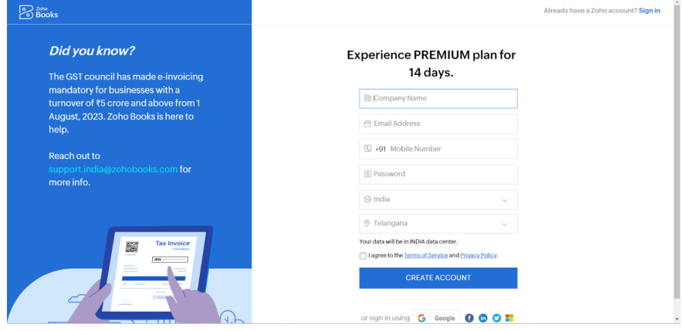

**To sign up for zoho books:**

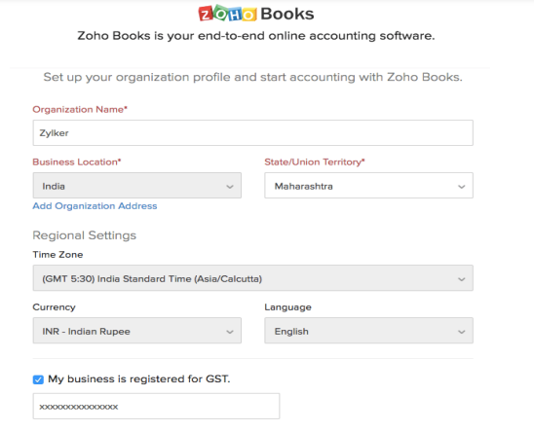

**ACTIVITY 2:Introduction**

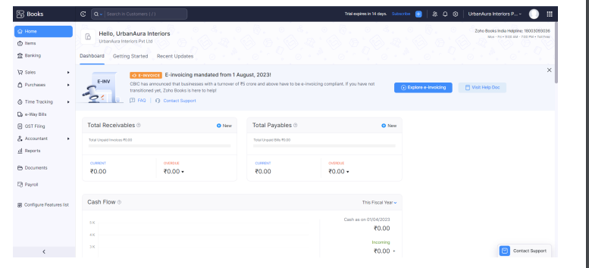

**Milestone 2: Service Creation:**

**ACTIVITY 2:Creation**

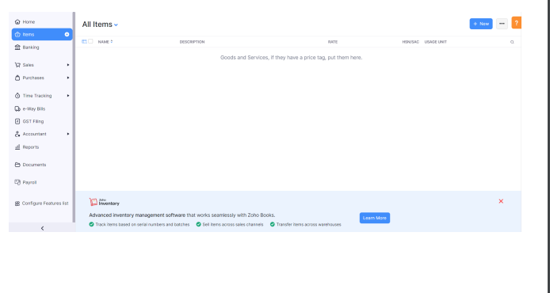

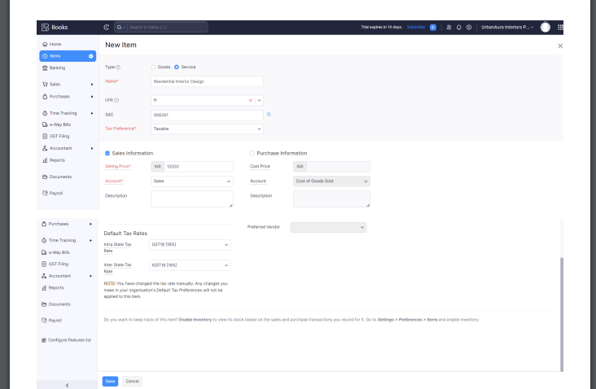

**Activity 2: Review of Items after Addition:**

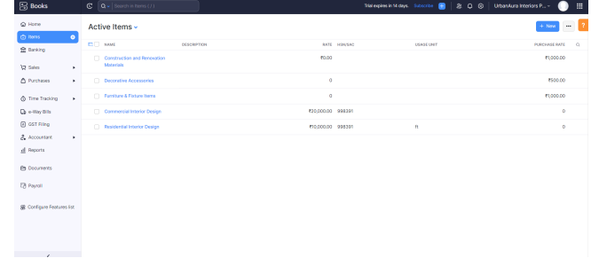

**Milestone 3: Vendors**

**Activity 1: Vendors Creation**

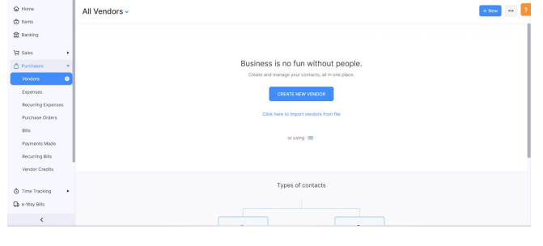

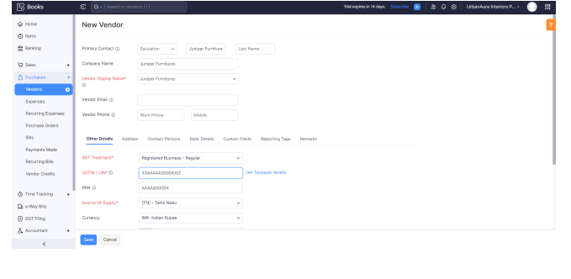

**Activity 2:**

**Review of Vendors List**

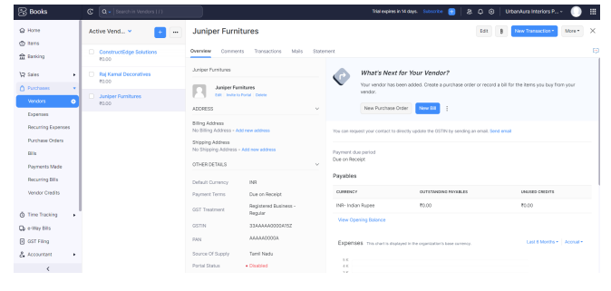

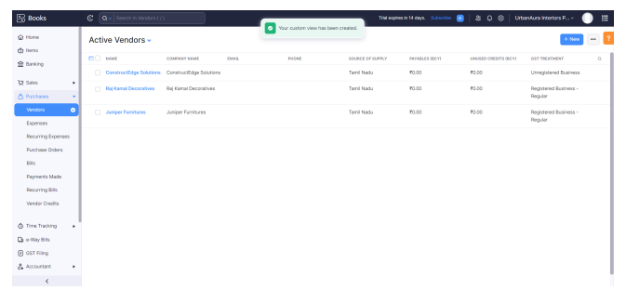

**Milestone 4: Purchases**

**Activity 1: Purchase Order Creation**

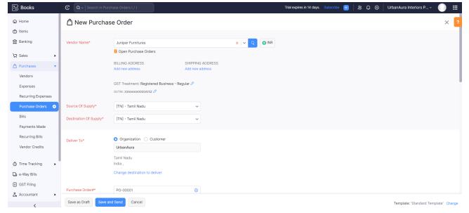

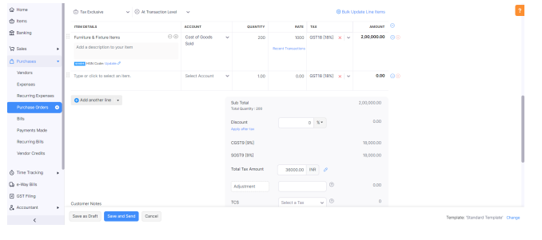

**Activity 2: Purchase Order to Purchase Bills Convertion**

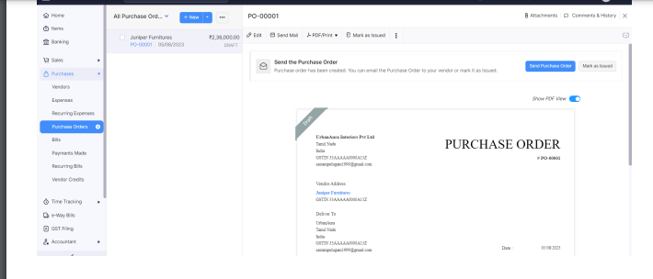

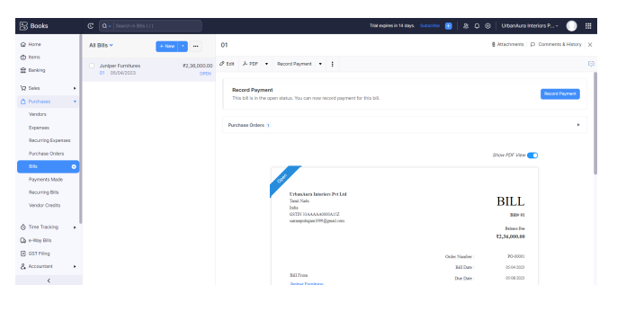

**Activity 3: Direct Vendor Purchases Bills Creation:**

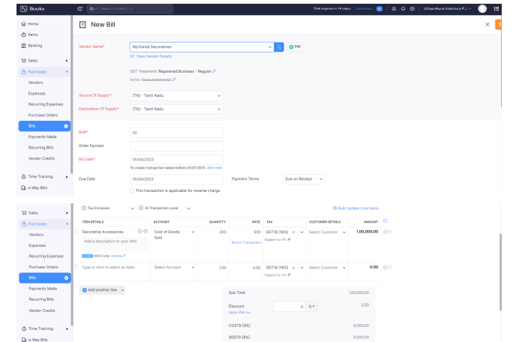

**Activity 4: Reconciliation of Open & Outstanding Bills**

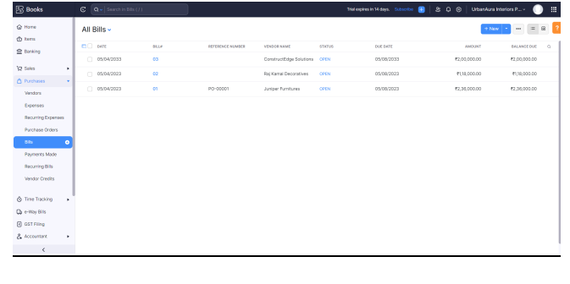

**Milestone 5: Customers**

**Activity 1: Customers Creation:**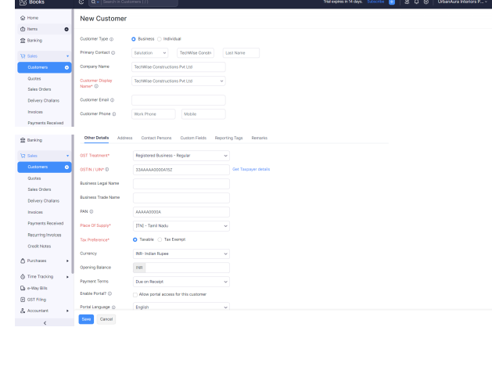

**Activity 2: Review the Customers List**

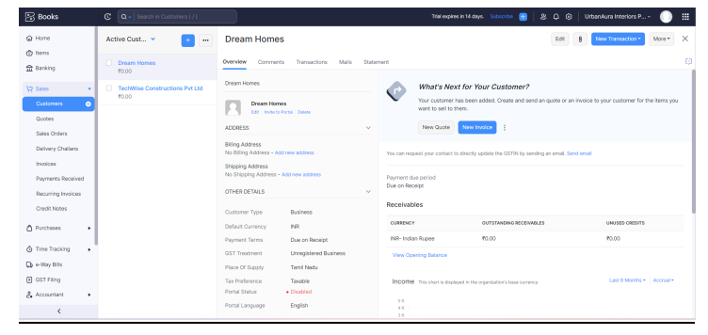

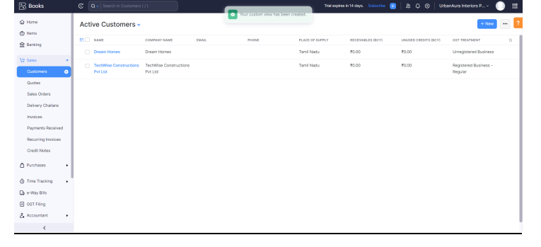

**Milestone 6: Sales**

**Activity 1: Sales Order Creation**

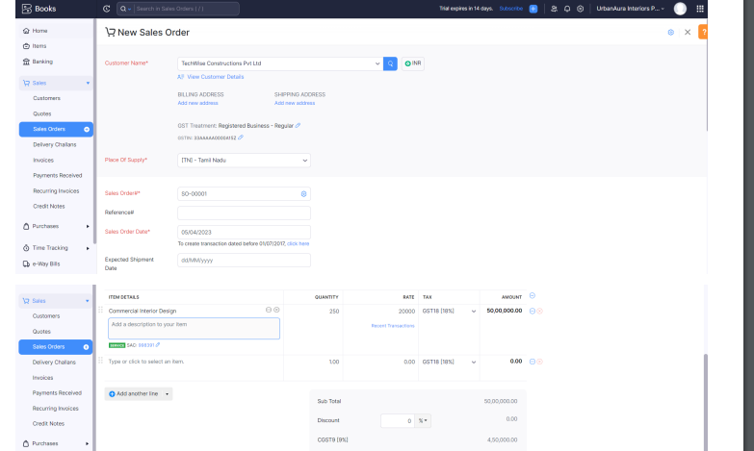

**Activity 2: Sales Order to Sale Invoice Convertion**

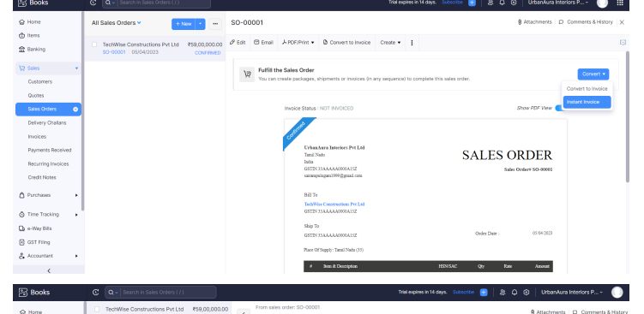

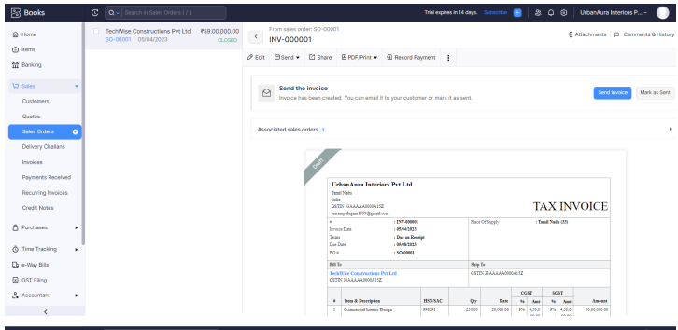

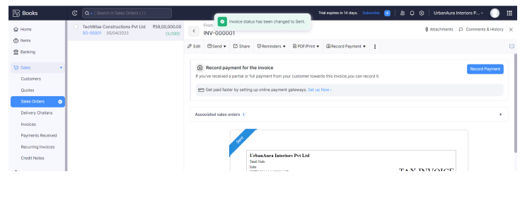

**Activity 3: Direct Sale Invoices**

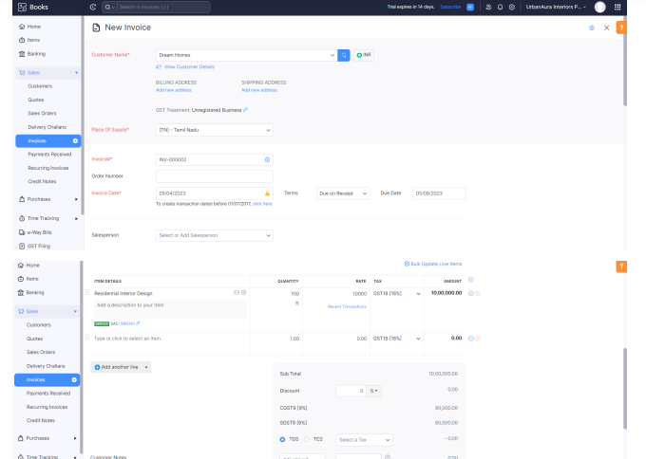

**Activity 5: Reconciliation of Open Invoices**

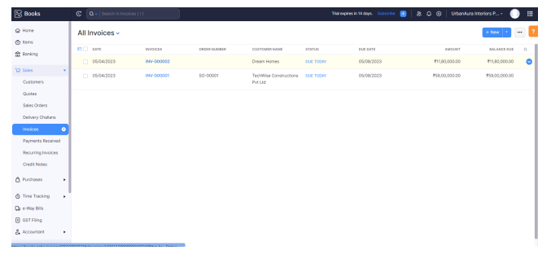

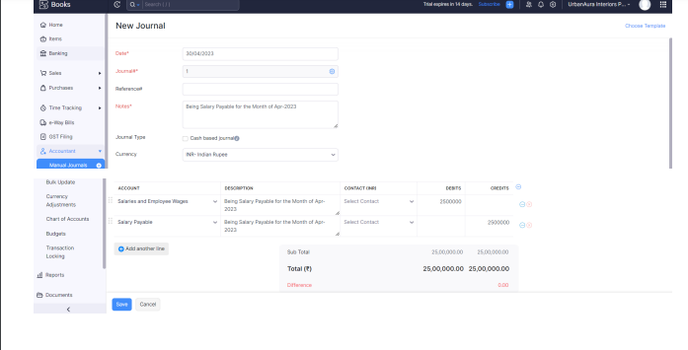

***4. Advantages :***

**Stylish look with good interiors and exterior feature Automatic version will give you more comfort. All the required basic features with this model like auto fold ORVM, Steering mounted control, electrically adjustable ORVM with music system and speakers. No noise while running.**

***Disadvantages:***

* + - No Front Armrest. While the Aura is the most feature-loaded sub-compact sedan in its segment, it lacks a front centre armrest. ...
    - Missing Features Like TPMS And Cruise Control. Addressed by Hyundai with launch of the Aura facelift.
      * S CNG And S AMT Carry A Higher Than Usual Price Premium Over Petrol Manual.

**5.Conclusion:**

ln conclusion, the analysis of housing prices in metropolitan areas serves as a multifunctional tool with wide ranging applications. It plays a pivot role in shaping urban landscapes, economic development, and individual choices, while also serving as a critical resource for policymakers and researchers. Recognizing the advantages and challenges associated with housing price analysis allows for more informed and responsible decision making in the complex world of real estate and urban development. The examination of housing prices serves as a vital tool for understanding the dyn market and itamics of the real estate market and its broader impact on society and the economy.

**Future scope:**

The scope of interior designers in India is wider than you think and is not limited to posh apartments or houses. Commercial projects include retail stores, shopping malls, hotels, pubs, cafes, corporate hospitals, colleges, and private schools. To exhibit Creativity, there are art galleries and designing a museum.

Despite limit demployment growth, about 8,200 openings for interior designers are projected each year, on average, over the decade. Most of those openings are expected to result from the need to replace workers who transfer to different occupations or exit the labor force, such as to retire.